Creative Spark
Higher Education Enterprise Programme

Online Delivery Handbook for Createathon Participants



*What you see marked in red are the parts you are encouraged to customise this template

How does the whole thing work?
All sessions will take place live on [insert name of your online meeting platform e.g., Zoom, Teams, Skype]. The week before the Createathon starts, you will receive an email with the links to join the workshops, as well as any other materials or links you need. You are expected to participate in all workshop sessions over the two intensive days. These classes will meet on [insert name of your online platform] and will utilize [insert name of your online tool e.g., Miro], so a strong internet connection will be necessary, and a laptop with working webcam is preferred.

What will the workshops be like?
As with anything Createathon related, you can expect that the sessions will be engaging and participatory! Our facilitators work hard to make each session engaging and beneficial. When can I meet new people and socialize?
You will become part of a cohort of participants led by dedicated facilitators. Within this cohort, you will have the opportunity for team building, networking and continued learning.

When will the workshops take place?
Workshops will be held on [insert days and times (change with global location of delivery team)]
[insert Createathon delivery dates (to and from)]

What version of [Zoom or other platform] should I be using?
We want to make sure that your Virtual Createathon experience is the best it can be. One thing you can do is to make sure that you have the most updated version of Zoom on your computer.. Go here to get the latest version.

- To download and install the Zoom Application: Go to https://zoom.us/download and from the Download Centre, click on the Download button under “Zoom Client For Meetings”. This application will automatically download when you start your first Zoom Meeting.

If you have a second device or screen available, you may want to have it ready to enhance your experience.

Will I need to be familiar with anything other than Zoom?
The Createathon uses digital tools, including [insert your chosen tools (e.g. Miro for whiteboard space)].
- For a guide on how to register yourself on Miro, please click here¹.
- Miro has also prepared an Participant Onboarding² course, but you need to be logged in to take part. Particularly important is the Participant Onboarding Template³ at the end of this course, so please work through it.

What supplies or materials will I need?
In addition to your laptop and any other device you want to use, make sure you have a journal or some paper and something to write with, a beverage or a snack, find a comfortable spot to sit, and be ready to participate in each session.

You’re recording these sessions — does that mean you’re recording ME?!
Your participation in the Createathon grants and conveys unto [insert your organisation’s details] all rights, title, and interest in any and all photographic images and video or audio recordings made during participation in the Createathon, including but not limited to royalties, proceeds, or other benefits derived from such photographs or recordings. If you do not agree to this photographic and video release, notify the facilitators, and please keep your camera off when any recordings are being made.

What are some participant Best Practices? [This is for Zoom]
- Plan to be on camera, if at all possible. It helps you fully participate in all the sessions and engage with the other participants and facilitators
- Make sure your name appears on your Zoom. Click the “participants” button, then your name to rename yourself if you need to.
- Use the chat function to ask any questions and interact with your fellow participants. If you need any technical help, use the chat function too.
- Even if you don’t want to have your camera on in the main sessions, please turn it on in the breakout rooms
- In the main session if you want to speak use the ‘raise hand’ (see below) to get the facilitator’s attention and unmute yourself. Feel free to use the other reactions too when appropriate.

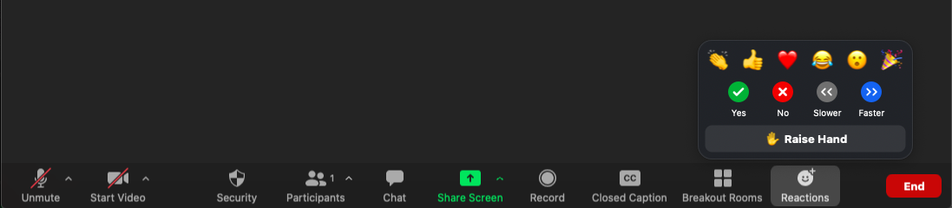

¹https://help.miro.com/hc/en-us/articles/360017571934-How-to-Register-a-Miro-Profile

²https://academy.miro.com/courses/participant-onboarding?link=text-hero-2&utm_campaign=funnel_eng_endu_11082021_en&utm_content=endu_v2-onboard&utm_medium=email_action&utm_source=customer.io

³https://miro.com/miroverse/participant-onboarding-playground/

